**Front-End Engineer Q5**

**Random Shape:** Create a button named ‘Draw Random Shape’. When this button is clicked, we will choose random shape from available (Square, Rectangle, Circle, Oval) and random color from available (Red, Green, Blue, Yellow) and random size from available (25px, 50px,75px,100px), use those values to draw the shape.

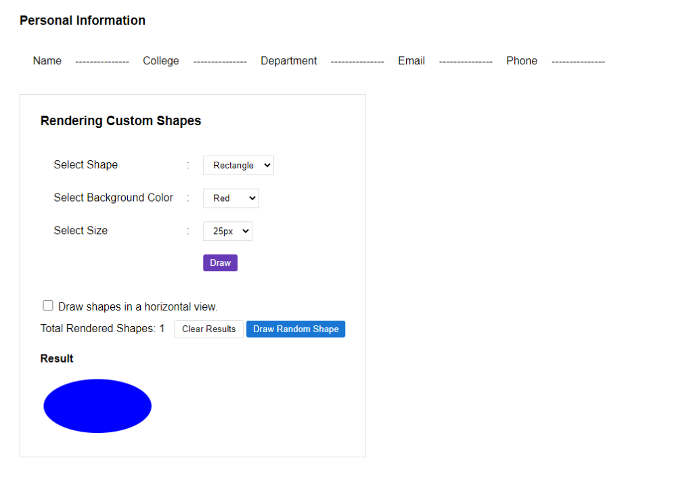

After clicking ‘Draw Random Shape button’, it will draw a random shape.

